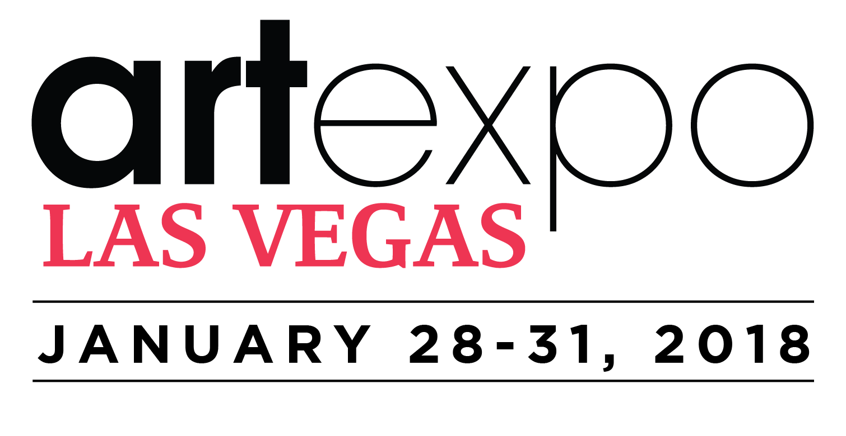
FOR IMMEDIATE RELEASE

Media Contact:
Linda Mariano
408-718-3730
linda.mariano@redwoodmg.com

ARTEXPO LAS VEGAS OFFERS ORIGINAL, HIGH-END ART
AT LAS VEGAS MARKET
Redwood Media Group brings highly acclaimed Artexpo brand—including
well-established artists and innovative, educational programming—to
Las Vegas beginning in Winter 2018
Las Vegas, NV – January 2, 2018: Redwood Media Group, the nation’s leader in exhibitions and event production, media, and marketing for the global fine art community, announces its highly anticipated debut during this year’s Las Vegas Market, taking place Jan. 28–31 in Pavilion 2 on the World Market Center campus in the heart of downtown Las Vegas. Artexpo Las Vegas represents an unprecedented opportunity for industry tastemakers from all corners of the art and design worlds to connect with world-class artists, respected galleries, and international art publishers.
The exhibition space within Pavilion 2 at Las Vegas Market is the ultimate destination for industry influencers from all spheres of art and design to source original paintings, prints, photography, sculpture, mixed media and glasswork exhibited by some of today’s elite artists, galleries, and emerging talents. Las Vegas Market attracts tens of thousands of buyers from 50 states and 76 countries.
“We look forward to producing a world-class fine art show during Las Vegas Market,” says Eric Smith, president of Redwood Media Group. "Designed specifically for those who source art to build their businesses—the only event of its kind
on North America’s west coast—Artexpo Las Vegas is an unprecedented opportunity for us to connect well-established artists, gallery owners, and publishers with a rapidly growing base of interior designers, architects, hospitality executives, and upscale retailers, a majority of whom don't attend markets in the East yet have millions of dollars in buying power."

Artexpo Las Vegas presents [MAGNETISM] as the curatorial theme for 2018: the extraordinary power of contemporary artists to allure trendsetting buyers and industry tastemakers in the most electric city in the Western United States. This theme forms a common thread throughout the special exhibits and programming that showcases exhibitors, art industry professionals, and select nonprofits and institutions. Specially curated programming includes the Spotlight Artist and Gallery Program, a focused look at several cutting-edge artists and galleries chosen by the Redwood Media Group selection committee; Meet the Artist events and live demonstrations; and Topics & Trends, cutting-edge seminars and high-quality professional development programming that offer expert perspectives on today’s most pressing industry challenges and the trends changing the way business is done—from matters of internet marketing and increasing competition to digital’s growing role in the marketplace.
Artexpo Las Vegas will present Art After Dark in tandem with the Las Vegas Market’s Monday Night Shopping Spree in Pavilions 2 and 3. Besides and extended day to walk the aisles and see some of the best of today’s offerings of contemporary fine art, the evening features live music for toe tapping, cocktails to sip, and live art presentations by renowned artists. The event is from 6 to 8 p.m., Monday, Jan. 29.
This year’s Topics & Trends discussions, conversations, and provocative discourses with leading artists, curators, designers, and art industry professionals include Yubal Marquez Fieites, Arte Collective owner and curator; Litsa Spanos, president of Art Design Consultants; Ruth-Ann Thorn, founder and owner of Exclusive Collections Galleries; Dorothy Willetts, interior designer and founder of Willetts Design Associates; and more.

The show opens at 9 a.m. Sunday, Jan. 28, and runs through Wednesday, January 31, at 4 p.m. The Opening Day Party and VIP Reception on Sunday, January 28, from 4-6 p.m. features innovative contemporary art, cocktails, and live entertainment. Artexpo Las Vegas offers complimentary admission for trade and media professionals. For further information on the show or to register for a complimentary Trade Pass online, visit artexpolasvegas.com. For more information on Redwood Media Group, visit redwoodmg.com.

GENERAL INFORMATION:

LOCATION
LAS VEGAS MARKET
PAVILION 2
475 S. Grand Central Parkway
Las Vegas, NV 89106

SHOW HOURS
OPENING DAY PARTY & VIP RECEPTION
Sunday, January 28 | 4:00PM - 6:00PM

MAIN SHOW HOURS
Sunday, January 28 | 9:00 AM - 6:00 PM
Monday, January 29 | 9:00 AM - 8:00 PM
Tuesday, January 30 | 9:00 AM - 6:00 PM
Wednesday, January 31 | 9:00 AM - 4:00 PM

About Artexpo Las Vegas
Since its launch in 2005, Las Vegas Market has become one of the largest trade buyer markets in the United States—and Artexpo is joining the party! Located in the heart of downtown Las Vegas’ vibrant art scene, Artexpo Las Vegas offers exhibitors exposure to the most diverse and unique industry sales and marketing platform in the Western U.S. and provides trendsetting buyers access to the most modern and contemporary artists and innovators in the world. Artexpo Las Vegas will host hundreds of contemporary artists, galleries, and art publishers from across the globe, showcasing exciting original work that can set market attendees’ business apart from the rest. It’s a first look at extraordinary fine art—painting, sculpture, photography, mixed-media work, glasswork, and more—from well-established exhibitors who will help attendees take their business to the next level.

For more information, visit www.artexpolasvegas.com

About Redwood Media Group
Since 2009, Redwood Media Group (RMG) has been revolutionizing the global fine art community by helping artists and gallery owners grow their businesses through fine art exhibitions and publications, art business education, mentoring, marketing, and social media. Today, RMG owns and operates six fine art shows: Artexpo New York, Artexpo Las Vegas, Spectrum Miami, Art San Diego, Art Santa Fe, and Red Dot Miami. Artexpo New York, the world's largest fine art trade show for 40 years and counting, attracts more than 40,000 art enthusiasts every year, including nearly 5,000 industry buyers. Spectrum Miami and Red Dot Miami take place during Miami Art Week, an annual attraction that draws over 100,000 art collectors to the city. Over the past eight years, RMG has welcomed hundreds of thousands of visitors to their events, sold millions of dollars' worth of art, and helped thousands of unrepresented and established artists launch or grow their careers. Aside from hosting multiple high-end art shows throughout the year, RMG also owns Art Business News.

For more information, visit www.redwoodmg.com, www.artbusinessnews.com, www.artexponewyork.com, www.artexpolasvegas.com, www.art-sandiego.com, www.spectrum-miami.com, www.artsantafe.com, and www.reddotmiami.com.

